Bicycle Count
Corner of 116th Street & Broadway
Manhattan, New York City

Tuesday, 20 November 2012

Substitute the titles and date above with the date(s) the count(s) were carried out

Subsitute the text below for one that corresponds to the count you carried out.
The New York City Department of Transpertation issued the Bicycle Master Plan in 2007, and has recently intensified the implementation of bicycle infrastructure, doubling the bicycle network with an additional 200 miles of facilities between 2008 and 2011. Bicycle commuting in New York City doubled between 2007 and 2011, and the DOT aims to triple this figure by 2017. An ambitious bike share program, with 600 stations and 10,000 bikes, is slated to roll out in March 2013.

To asses the need for cycling facilities in Columbia University’s Morningside Heights campus, the University has asked students of the Urban Planning program to provide information on cycling in the area. This repert summarizes the bicycle count carried out on Monday ??? November and Tuesday ???? November 2012. The photographic count allows us to count and recount, and re-examine various aspects related to bicycle transpert. The repert concludes with specific infrastructure and policy recommendations.

Substitute the images and the map for others of the count area. Images obtaned from google maps

The count was carried out on the corner of X Street and Y Avenue
.
- Graphs
Substitute these graphs for the new ones by copying from the spreadsheet and copying here.

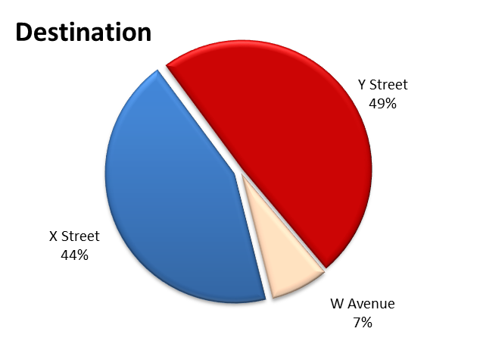

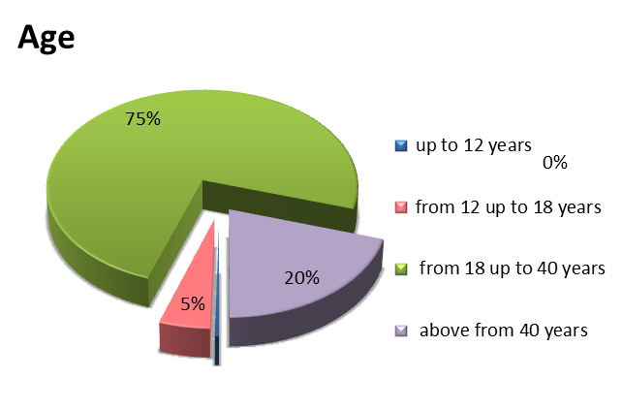

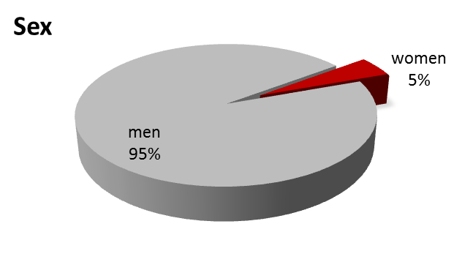

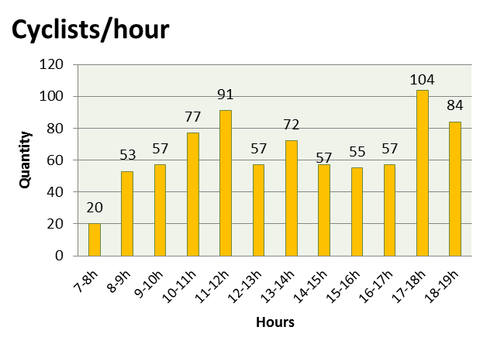
average = 65
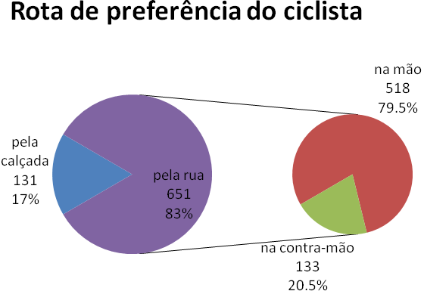

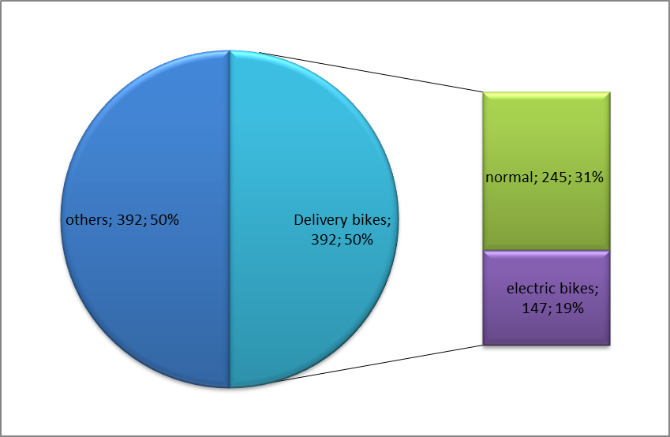
- Photographs
Substitute the images with those from the photos of your count according to the item in the caption.
The fotos should be 300x200 pixels / 72dpi
Substitute the red Xs with the new data.

x cyclists in 12 hours
Average of x cyclists per hour

x going to X Street x %

x going Y Street x %

x going to W Street x %

x men x %

x women x % / x % of private (not delivery)

x children riding in seats or other.

x up to 12 years x %

x from 12 to 18 years x %

x 18 to 40 years, x %

x above 40 years, x %

1st hour x cyclists 7 - 8 AM

2nd hour x cyclists 8 – 9 AM

3rd x cyclists 9 - 10

4th hour x cyclists 10 - 11

5th hour x cyclists 11 – 12 AM

6th hour x cyclists 12 - 13 PM

7th hour x cyclists 13 - 14 PM

8th hour x cyclists 14 – 15 PM

9th hour x cyclists 15 – 16 PM

10th hour x cyclists 16 – 17 PM

11th hour x cyclists 17 – 18 PM

12th hour x cyclists 18 – 19 PM

x Total on the sidewalk x %

x Total on street x %

x Total on street against traffic x %
(x % of those on street)

x Delivery, x %

Being:

x normal, x % of total / x % of delivery

z
x cargo bikes, x % of total / x % of delivery

x tricycle, x % of total / x % of delivery

Remova ou adicione categorias de acordo com a necessidade ou expressividade.

x use helmets, x %

x use backpacks or bags, x %

x with passengers, x %

x Folding bikes, x %

x Rollerskates/rollerblades, x %

x Skateboards, x %

All of the photos are available at: web address of album with all fotos.
All of the fotos are also available in high definition – to obtain these, please contact:
Email address for contact

- Just numbers:
Substitute the red Xs for new data.

x cyclists in 12 hours
Average of x cyclists per hour

x going to X Street x %
x going Y Street x %
x going to X Avenue x %

x men x %
x women x % of total / x % of private (non-delivery)

x children riding in seats or other.
x from 12 to 18 years x %
x from 18 to 40 years, x %
x above 40 years, x %

1st hour x cyclists 7 - 8
2nd hour x cyclists 8 - 9
3rd hour x cyclists 9 - 10
4th hour x cyclists 10 - 11
5th hour x cyclists 11 - 12
6th h x cyclists 12 - 13
7th h x cyclists 13 - 14
8th h x cyclists 14 - 15
9th h x cyclists 15 - 16
10th h x cyclists 16 - 17
11th h x cyclists 17 - 18
12th h x cyclists 18 - 19

x Total on the sidewalk x %
x Total on street x %
x On street against traffic x % of on street / x % of total

x Delivery bikes; being: x %
x normal x % of total / x % of delivery
x cargo bikes x % of total / x % of delivery
x tricycles x % of total / x % of delivery
x Delivery against traffic x % of those against traffic
x Delivery on the sidewalk x % of those on the sidewalk

x with helmet x %
x with backpack or bag x %
x with passenger x %
x folding bikes x %
x rollerskates/blades x %
x skateboarders x %
x with cycling clothing x %
Many pedestrians

Substitute this foto with one from the count

For further information:

Associação Transporte Ativo


www.ta.org.br
blog.ta.org.br
Substitute this logo and contact info with those of your organization

In partnership with:


http://www.itdp.org
and this with your partner or sponsor’s logo.

This bicycle count was carried out using methodology created by the
Associação Transporte Ativo

